NEUMERA
Longitudinal women’s health & AI coaching
Perimenopause / Menopause & Vitality Module
Vitality Engine — functional architecture, screen layouts, and feature build notes
For dev-team and compliance review

Purpose of this document. This spec describes the Perimenopause/Menopause & Vitality module as a symptom-correlation engine with an education layer and a menopause overlay on the existing platform AI coach. It covers the module architecture and per-feature build, three reference screen layouts (the “Today” hero, the mood-support path, and the transition-staging view), and a ready-to-run Cowork prompt for producing the full diligence-grade specification. Screens shown are design references for the build team, not final production assets.
Stage framing. User-facing, this stage reads: navigating the hormonal turbulence of perimenopause and menopause — decoding disruptive symptoms and protecting long-term vitality as the body’s rhythms shift. The internal “sharpest wedge” framing is retained for pitch and strategy contexts, not the product surface.

0 · Data Privacy & Zero-Retention
Privacy is a first-class design principle across every Neumera module, not a compliance afterthought. The commitments below are inherited from Neumera’s core platform and privacy architecture and restated here so this document stands on its own for diligence review. They govern every feature in this specification.

Zero-retention AI
The AI keeps nothing; your account does. All AI inference runs on AWS Bedrock over private connectivity (VPC PrivateLink), under a signed Business Associate Agreement verified through AWS Artifact, with no retention of prompts or outputs by the model or the provider. The inference layer is stateless; durable value lives only in the user’s own longitudinal record. This is how zero-retention inference is reconciled with durable longitudinal storage — the record persists, the AI does not.

Trust domains and the de-identification gate
Data is separated into three trust domains with an isolated linkage store, so identity and health signal are never co-resident where the AI can see both. A fail-closed de-identification gate sits on any payload crossing from the identity zone to Bedrock: if the gate cannot strip identity, the request does not proceed.
Precision note. The platform’s privacy claims currently rest on pseudonymized status — not “de-identified” or “anonymized” — pending completion of the HIPAA §164.514(b)(1) Expert Determination scoping the AI-bound payload. Documentation and UI copy should use “pseudonymized” until that determination completes.

Regulatory posture
The FTC Health Breach Notification Rule is the primary regime at launch (no covered-entity or business-associate relationship, and no EU/UK presence at launch); HIPAA Security Rule practices, Washington’s My Health My Data Act, and GDPR readiness are maintained as the footprint expands, backed by an incident-response plan with breach-notification steps.

Commercial data boundary
The B2B provider-advertising layer targets geography and life-stage context only — never individual health signals. No module’s health data is used for ad targeting.

Highest-sensitivity data in this module
Vasomotor (hot-flash), mood, and sleep logs, transition-staging derived from cycle-gap data, any user-logged hormone results, and sexual, vaginal, and urinary (genitourinary / GSM) symptom data. The sexual-health and GSM data is treated at the highest-sensitivity tier, alongside the platform’s most protected categories; mood data and the low-mood clinical-escalation path are handled with heightened care as mental-health-adjacent signals.

1 · Architecture — the Vitality Engine
As with Athlete, these are not five separate features — but the shape is different, and the difference drives the build. This is a symptom-correlation engine with an education layer, and unlike Athlete it has almost no clean wearable-derived score. The signal here is largely self-reported (hot flashes, mood) with wearable enrichment (sleep, and a partial nocturnal hot-flash proxy). So the engine’s job is not to compute a number — it is to capture fast, then surface the connections between symptoms she would never spot herself.
The differentiator is the chain. Night sweats fragment sleep → broken sleep worsens mood. She experiences three separate miseries and never sees they are one linked pattern. Showing her that chain is the product — the way N-of-1 pattern detection was the product for Athlete. The pipeline: capture (symptom logs + wearable) → derive (burden trends + cross-symptom correlation) → stage (position in the transition) → surface (patterns + stage-appropriate education).

Feature-to-stack mapping
Confirmed stack: Laravel API core + Python/FastAPI internal ML microservice (async boundary, Python internal-only) + Flutter client. Ingestion via HealthKit / Health Connect (Flutter health plugin) and Terra API for cloud wearables (Oura, Garmin, Whoop, Fitbit).
- Hot flash tracking — The critical interaction is one-tap in-the-moment logging, reachable from home and ideally an OS home-screen widget/complication (she will not fill a form mid-flush). Store timestamp + optional intensity (Flutter → Laravel). Optionally enrich with a nocturnal proxy from wearable skin-temperature and HR spikes (Oura, newer Garmin) — specify as experimental enrichment, never source of truth.
- Sleep disturbance — Sleep stages and fragmentation via Terra + HealthKit/Health Connect. The engine’s value is correlating fragmentation against logged night-sweat events, not reporting raw hours.
- Mood changes — One-tap daily mood check-in plus optional notes. FastAPI correlates mood against the prior night’s sleep and vasomotor load.
- Hormonal-transition analysis — The one to handle carefully. You cannot measure hormones from a wearable, and in perimenopause hormones are erratic by definition. Frame as (a) transition staging informed by STRAW+10, driven by observed cycle-gap changes from the Cycle engine, and (b) optional integration of user-logged at-home test results (FSH, estradiol) plotted over time. UI language is “where you are in the transition” and observable facts (“cycles lengthening”), never inferred hormone levels.
- Menopause education — The biggest compliance surface. Content is clinically reviewed and human-authored (EVP clinical-programs lane), served via retrieval over vetted material; Bedrock selects and contextualizes what is relevant to her stage but never free-generates medical content. An LLM improvising on HRT or cardiovascular risk is a serious liability.
- Sexual, vaginal & urinary health (GSM) — a full genitourinary-symptom domain (vaginal dryness, painful sex, libido, urinary symptoms) feeding the same correlation engine, with its own normalization, route-to-care, and highest-sensitivity privacy treatment. Covered in detail in Section 6.

Three things this module has that Athlete did not
- A mood safety path. Perimenopause carries a documented elevation in depressive symptoms. Sustained low mood should trigger a gentle, non-alarmist nudge toward professional support — not a diagnosis, not crisis intervention (Section 4).
- Real accessibility stakes. Users skew 40s–50s+. Larger default type, high contrast, large tap targets, minimal-step interactions — first-class design requirements, not a later polish pass.
- Adjacency to diagnosis. Menopause is a clinical determination. Staging and symptom tracking are informational wellness; copy stays on that side (“not a diagnosis; discuss with your clinician”), consistent with the Avoiding-Pregnancy and overtraining-syndrome discipline.

2 · The AI coach — an overlay, not a new component
The Neumera AI coach is already a platform-wide component, so building a separate coach here would be duplicative — but invoking it here is not. Per the coach patent, it is one engine with layered base-prompt-plus-life-stage-overlay orchestration, running on AWS Bedrock, zero-retention, cost-routed across model tiers, and metered by subscription tier (user-initiated coaching counts against the cap; automated daily summaries are off-quota). It already spans all six stages.
The correct move: the shared coach gets a menopause life-stage overlay. What is genuinely module-specific and worth specifying:
- The menopause prompt overlay — tone (warmer, less performance-driven than Athlete), domain framing, and hard boundaries on what it may say.
- The retrieval corpus — the coach’s menopause answers draw from the EVP’s clinically-reviewed education content, not free generation. The coach is the conversational front door to that corpus.
- Module-specific guardrails — no HRT dosing guidance, no hormone-measurement claims, and the low-mood clinical-escalation path. The patent’s post-inference guardrail filtering and clinical escalation is exercised hardest here.
- The off-quota daily summary — the correlation insight on the hero screen (“your mood days follow your broken sleep”) is coach-authored, and per the pricing model those automated summaries do not count against her interaction cap.
In practice the coach is already present on the hero screen — it wrote the insight card and it routes the stage-selected education — and it is the voice of the mood-support screen (Section 4). It does not need reintroducing; it needs a menopause overlay and the tightest guardrails of any stage.

3 · Screen layout — the “Today” hero
The screen a woman lands on when she opens the module. Built differently from Athlete: logging leads, not a computed score.
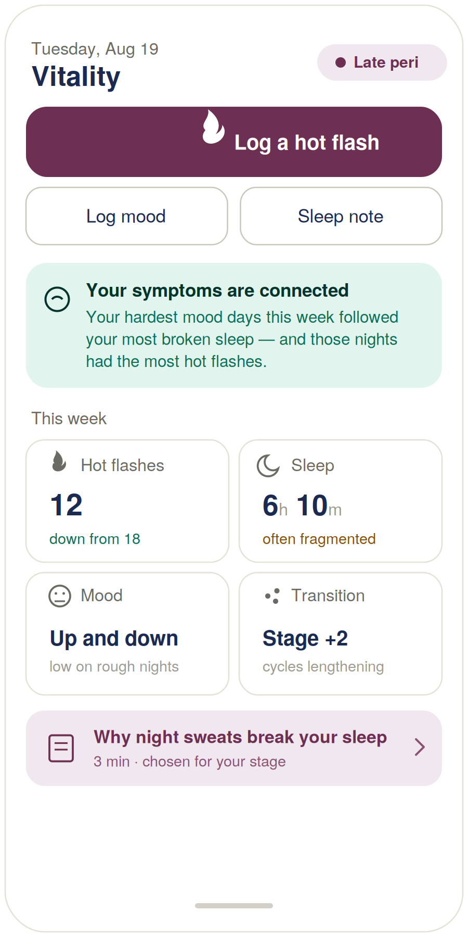
Figure 1 — Vitality module “Today” hero view (design reference).

Build notes
- Logging is the hero, not a metric. The big “log a hot flash” button leads because capture-in-the-moment is the foundation — if she cannot log a flush in one tap while it is happening, every downstream insight is starved.
- The connection insight is the product. The teal card (mood days followed broken sleep, which followed night-sweat clusters) is the cross-correlation the FastAPI engine exists to find, and it is coach-authored. Everything else is inputs to it.
- Honest hormonal framing. “Transition · Stage +2 · cycles lengthening” is staging language, not a hormone reading — an observable fact, not an inferred estrogen level.
- Education is stage-selected, not generic. “Chosen for your stage” is the retrieval-and-route pattern: vetted content, the AI picks what is relevant, the AI does not write it.
- Calmer, larger, warmer. Bigger type, more breathing room, plum-and-teal rather than performance greens/reds. The demographic and emotional register differ from Athlete and the app should feel like it.

4 · Mood safety path
The highest-stakes screen in the module, and coach-voiced. It surfaces when sustained low mood is detected.
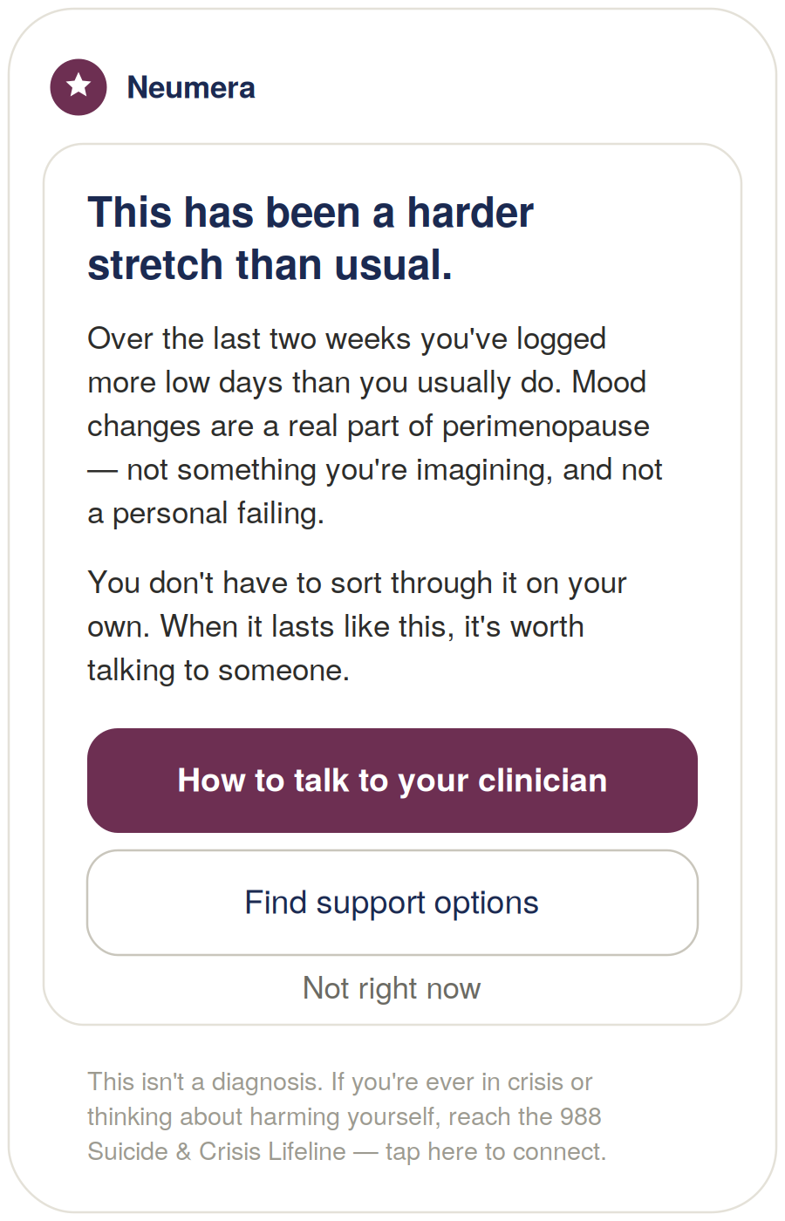
Figure 2 — Mood-support prompt, coach-voiced (design reference).

Build notes
- Names the experience without diagnosing it. “A harder stretch,” “more low days than usual” — never “you may have depression.”
- Normalizes. “A real part of perimenopause, not something you’re imagining, not a personal failing” — the single most therapeutic thing the product can honestly say here.
- Routes toward humans, not deeper into the app. The primary action helps her prepare to talk to a clinician; the right outcome is a real conversation with a professional, not more engagement with Neumera.
- Quiet crisis footer. Always reachable, never alarmist, and it makes no promises about confidentiality or outcomes it cannot keep.
Two decisions for the clinical lane (EVP) to own: the detection threshold (how many low days, over what window, before it surfaces — conservative enough not to cry wolf) and the frequency cap (it should appear rarely and never nag). These are clinical-judgment calls, not engineering defaults.

5 · Transition-staging view
Where the “we don’t measure hormones” discipline has to be visible on the glass.
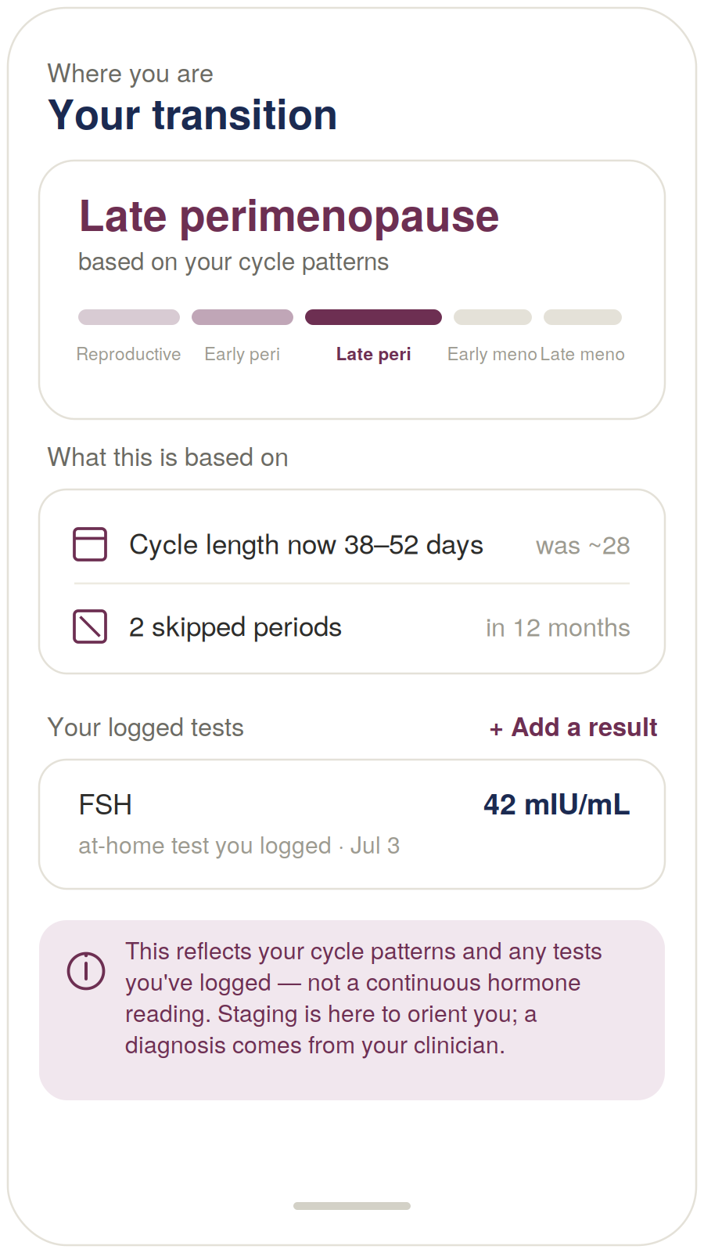
Figure 3 — Transition-staging view (design reference).

Build notes
- A five-step track, not a number. Reproductive → early peri → late peri → early meno → late meno is STRAW+10 rendered for a layperson — she sees where she is on a journey, not false precision.
- It shows the receipts. “What this is based on” lists observable facts from her own cycle data (length 38–52 days, was ~28; two skipped periods). The label reads “based on your cycle patterns,” never “based on your hormone levels.”
- Logged tests are labelled as self-entered. FSH appears only because she entered an at-home test, marked “at-home test you logged” — not something Neumera measured. That is the difference between an honest product and a claim you would have to defend to the FTC.
- The footer is load-bearing. “Reflects your cycle patterns and any tests you’ve logged — not a continuous hormone reading… a diagnosis comes from your clinician.” Same discipline as the mood screen.

6 · Sexual, Vaginal & Urinary Health (GSM)
Genitourinary syndrome of menopause (GSM) is the modern umbrella term — adopted by NAMS and ISSWSH, replacing “vaginal atrophy” — for the symptom cluster driven by the same estrogen decline: vaginal dryness and burning, painful sex, libido change, and urinary symptoms. It belongs in the Vitality Engine because it is a menopause symptom domain, and it is one of the highest-value additions the module can make: it affects a large majority of women in the transition, it is severely under-reported and under-treated, and unlike hot flashes it is usually progressive — it does not resolve on its own. A silent, worsening, treatable problem no one is discussing: naming it is the product.

How it fits the engine
GSM slots in as a new tracked symptom domain feeding the same capture → correlate → stage → surface pipeline, with the same retrieval-grounded EVP education layer and the same route-to-clinician pattern already built for the mood path. The module’s job here is narrow and high-value: recognize it (this is GSM, not “aging to endure”), normalize it (common, physical, treatable, not her fault), and bridge her to care.

Treatment is medical — the module bridges, it does not treat
The treatments that work — low-dose vaginal estrogen, DHEA, ospemifene, non-hormonal moisturizers and lubricants, and pelvic floor physical therapy — largely come from a clinician. So the module must not position itself as treating GSM. It tracks, normalizes, educates (from the vetted EVP corpus, never free-generated), and routes to the right kind of provider — giving her the language and the confidence to raise a topic she, and often her clinician, would otherwise never bring up.

Four design disciplines this domain demands
- Radical de-stigmatization. The most intimate, most shame-laden cluster in the platform. Clinical, warm, matter-of-fact tone — common, physical, treatable, not a personal failing. Get the tone wrong and she never logs again.
- Highest-sensitivity privacy. Sexual-health and sexual-activity data sits at the same tier as the Cycle intent-door data; it is handled at the highest-sensitivity tier (Section 0), and the UI signals that plainly.
- Urinary triage. GSM urinary symptoms are chronic and estrogen-driven, but the same symptoms — burning, urgency, frequency — can be an acute UTI needing prompt care. A possible-infection pattern routes to care promptly rather than being logged as a menopause trend. (Recurrent UTIs are themselves a GSM feature vaginal estrogen reduces — an education and route angle too.)
- Libido, done honestly. Not a “boost your desire” gimmick. Desire in the transition is multifactorial — the pain-avoidance cycle, sleep, mood, stress, relationship, medications — so the framing is holistic and non-judgmental, centering her comfort and experience, never performance or a partner’s expectations.

Screen — intimate-health tracking & normalization
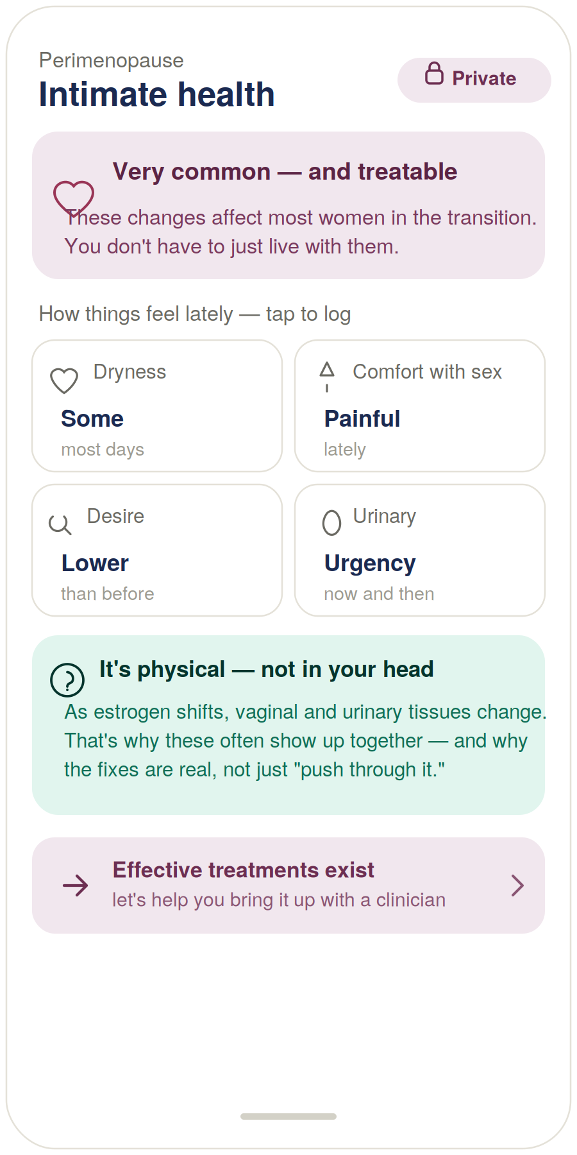
Figure 4 — Intimate-health tracking and normalization (design reference).
- Normalization leads. “Very common — and treatable … you don’t have to just live with them” is the first thing on the screen, and the heart of the design.
- Plain, non-judgmental logging. Dryness, comfort with sex, desire, and urinary symptoms are logged in gentle everyday language, one tap each.
- “It’s physical — not in your head.” The coach insight ties the cluster to estrogen and tissue change — validating that the symptoms are real and so are the fixes.
- A discreet privacy signal. The “Private” marker reassures her that this most-sensitive data is protected.

Screen — worth bringing up (route to care)
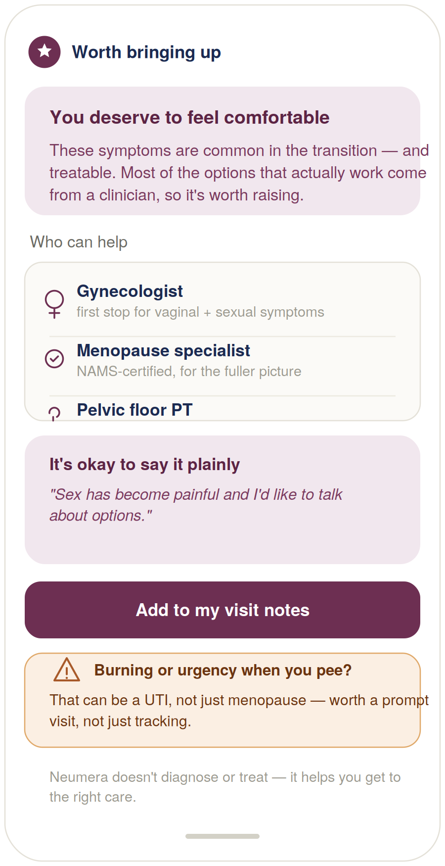
Figure 5 — Route-to-care and prepare-to-raise-it (design reference).
- It bridges to treatment. “Most of the options that actually work come from a clinician” — honest about where the fixes live, and it routes her there.
- Provider-type guidance. Gynecologist, NAMS-certified menopause specialist, or pelvic floor PT — women often don’t know who to ask.
- It helps her say it. A plain script (“sex has become painful and I’d like to talk about options”) and an “add to my visit notes” action — the specific help this population needs to start the conversation.
- The urinary-triage caution. Burning or urgency is flagged as a possible UTI worth a prompt visit — route, not diagnose — under a footer stating Neumera does not diagnose or treat.

7 · Cowork build prompt (consolidated)
Drop this into Cowork to produce the full diligence-grade Vitality module specification. The five screens above are referenced as Exhibits A–E.
Task
Produce a diligence-grade functional and technical specification document for the Perimenopause/Menopause & Vitality life-stage module of the Neumera women’s health app, for our contract dev team and compliance reviewers. Match our established document system: navy and Sand Gold brand colors, Fraunces for headlines, Inter for body. First review our existing spec documents (the Athlete module spec, the Cycle/Fertility Section 7 functional spec, the health data ingestion architecture spec, the graceful-enrichment doc, and the AI coach patent specification) so this module is stylistically and architecturally consistent — it must interoperate with the Cycle & Fertility engine for staging and with the existing platform AI coach.
Architecture
Specify the module as a single Vitality Engine with read-surfaces, not independent features. Pipeline: capture (symptom logs + wearable enrichment) → derive (symptom-burden trends and cross-symptom correlation) → stage (position in the menopausal transition) → surface (patterns + stage-appropriate education). The differentiator is cross-symptom correlation — showing how hot flashes, sleep fragmentation, and mood move together. There is no wearable-derived readiness score; the home surface leads with one-tap symptom logging and a coach-authored correlation insight.
The six surfaces
Hot flash (vasomotor) tracking, sleep disturbance monitoring, mood-change tracking, hormonal-transition analysis, menopause education, and sexual/vaginal/urinary health (genitourinary syndrome of menopause, GSM).
Stack
Laravel API core, internal Python/FastAPI ML microservice (async boundary, Python internal-only), Flutter client. Sources: HealthKit / Health Connect via the Flutter health plugin, Terra API for cloud wearables (Oura, Garmin, Whoop, Fitbit), plus manual symptom/mood/sleep logging. AI on AWS Bedrock under the zero-retention pattern with the de-identification gate on any payload crossing to Bedrock.
Per surface, specify
Inputs and sources, computation and where it lives (deterministic FastAPI stats vs. rules vs. Bedrock), durable-record storage, and Flutter UI. Hot flash: one-tap in-the-moment logging from home and an OS home-screen widget/complication; timestamp + optional intensity; optional nocturnal proxy from wearable skin-temp/HR spikes (Oura, newer Garmin) specified as experimental enrichment, never source of truth. Sleep: stages/fragmentation via Terra/HealthKit; value is correlation against logged night-sweat events. Mood: one-tap daily check-in plus notes; FastAPI correlates against prior-night sleep and VMS load. Hormonal-transition: NO hormone measurement from wearables — frame as STRAW+10-informed staging driven by observed cycle-gap changes, plus optional integration of user-logged at-home test results (FSH, estradiol); UI shows observable facts (“cycles lengthening”) and a five-step stage track, never inferred hormone levels. Education: clinically reviewed, human-authored corpus (EVP lane) served via retrieval; Bedrock selects and contextualizes by stage but never free-generates medical content.
Sexual, vaginal & urinary health (GSM)
Specify GSM as a full symptom domain feeding the same correlation and education pipeline, not a standalone feature. Track vaginal dryness/burning, comfort with sex (dyspareunia), libido/desire, and urinary symptoms in plain, non-judgmental language with one-tap logging. Normalization is a first-class design requirement (common, physical, progressive, treatable, not a personal failing), and de-stigmatizing tone is load-bearing. Treatment is medical: the module educates from the retrieval-grounded EVP corpus (e.g. low-dose vaginal estrogen, DHEA, ospemifene, moisturizers/lubricants, pelvic floor PT) and routes to the right provider type (gynecologist, NAMS-certified menopause specialist, pelvic floor PT), but never claims to treat and never gives dosing guidance. Include a “prepare to raise it” tool (plain scripts + add-to-visit-notes). Urinary triage: distinguish chronic GSM urinary symptoms from a possible acute UTI (burning, urgency, frequency) and route the latter to prompt care rather than logging it as a trend. Privacy: sexual-health and GSM data is handled at the highest-sensitivity tier (see the module’s Section 0).
AI coach — overlay, not a new component
Specify the module’s coaching as the existing platform AI coach (per the patent’s layered base-prompt + life-stage-overlay orchestration, Bedrock, zero-retention, cost-routed, tier-metered) with a menopause life-stage overlay. Specify: (1) the overlay’s tone and domain framing; (2) that its menopause answers are retrieval-grounded in the EVP education corpus, not free-generated; (3) module-specific guardrails — no HRT dosing guidance, no hormone-measurement claims, and the low-mood clinical-escalation path; (4) that the daily correlation insight is a coach-authored automated summary and therefore off-quota, while user-initiated coaching counts against the tier cap.
Module-specific requirements
Mood safety path — perimenopause carries elevated depressive-symptom risk; specify a gentle, non-diagnostic prompt toward professional support when sustained low mood is detected (Exhibit B). The detection threshold and surfacing frequency are clinical-lane (EVP) decisions and must be conservative; include a quiet, always-available crisis resource that makes no confidentiality or outcome guarantees. Sexual/vaginal/urinary (GSM) — de-stigmatizing tone and highest-sensitivity privacy are first-class requirements; the module educates and routes but never treats or gives dosing; urinary symptoms suggesting infection route to prompt care rather than tracking. Accessibility — users skew 40s–50s+; larger default type, high contrast, large tap targets, minimal-step interactions as first-class requirements. Compliance framing — symptom tracking and staging are informational wellness, not a diagnosis; copy stays on the wellness side. Phased build: deterministic logging, correlation, and staging first; wearable VMS proxy and learned models deferred.
Reference exhibits to include and build against
Exhibit A — “Today” hero screen (Figure 1): one-tap hot-flash logging as primary action; secondary mood/sleep logging; a coach-authored cross-symptom correlation insight; a weekly four-surface snapshot (hot flashes with trend, sleep with fragmentation flag, mood in plain language, transition stage); a stage-selected education card. No computed hero score. Larger type, calmer palette.
Exhibit B — Mood support screen (Figure 2): coach-voiced, non-diagnostic message acknowledging a hard stretch and normalizing perimenopausal mood change; primary action helps her prepare to talk to a clinician; secondary offers support options; quiet always-available crisis resource in the footer.
Exhibit C — Transition-staging screen (Figure 3): five-step stage track (reproductive → early peri → late peri → early meno → late meno) with current stage marked; a “what this is based on” list of observed cycle facts; a user-logged at-home hormone-test section clearly labelled as self-entered; a footer stating this is not a continuous hormone reading and not a diagnosis.
Exhibit D — Intimate-health tracking & normalization screen (Figure 4): a normalization banner leading (“very common — and treatable; you don’t have to just live with them”); plain one-tap logging of dryness, comfort with sex, desire, and urinary symptoms; a coach insight tying the cluster to estrogen/tissue change (“it’s physical — not in your head”); a discreet “private” signal; a route-to-care nudge.
Exhibit E — Worth-bringing-up / route-to-care screen (Figure 5): honest that effective treatments come from a clinician; provider-type guidance (gynecologist, NAMS-certified menopause specialist, pelvic floor PT); a plain script and an “add to my visit notes” action to help her raise it; a urinary-triage caution flagging a possible UTI for prompt care; a footer stating Neumera does not diagnose or treat.

Practical note. Cowork cannot ingest the five rendered screens as images from the chat directly — either describe Exhibits A–E in the prompt (as done above, enough to reconstruct them) or attach Figures 1–5 from this document to the Cowork session as visual references.

